What Is Weather And How Do We Predict It?
Weather simply refers to the condition of the air on earth at a given place and time - whether it is warm or cold, dry or wet, blowing or calm. The condition of air and how it acts to create weather is influenced primarily by two things - heat (the sun) and water.
Weather on earth starts with the sun. The sun's heat warms our atmosphere and causes two things to happen:
- water evaporates into the air
- air rises
As air rises, its temperature drops. As the moisture in the air cools, it condenses into tiny suspended droplets, forming clouds. The droplets inside the clouds become larger a more moisture is evaporated into the air. Eventually, they are too heavy to remain suspended and fall to earth as precipitation - rain, snow, sleet or hail.
  - Fronts and Air Masses
Weather maps show the positions of air masses. An air mass is a very large body of air that has similar properties. Air masses move, so they can be tracked over time. They are clues to the future temperature, moisture level and air pressure of the area into which they are moving.
When one air mass meets another, the air in different masses usually does not mix because the properties of the air are different. A boundary, or front, forms between the two air masses. Stormy weather often occurs along fronts.

Cold Front- A cold front forms where a cold air mass moves into a warm air mass. Cold air contracts, becomes more dense, and thus heavier than warm air, so the cold air pushes underneath the warm air. Cumulus clouds and showers or thunderstorms may be scattered along cold fronts. As the front passes, the wind changes direction. Skies begin to clear, and the temperature usually drops.

Warm Front- A warm front forms where a warm air mass moves into a cold air mass. Because the warm air is less dense, it slides up and over the colder air. At first, cirrus clouds might appear. They may be followed by stratus clouds and some precipitation, either rain or snow. When the front passes, the sky clears and the air pressure rises. Temperatures also rise as warm air replaces cold air.

Stationary Front- Even though air masses often move, sometimes they don't, resulting in a stationary front. Precipitation and weak winds usually occur in areas with stationary fronts.
  - High and Low Air Pressure
Certain weather conditions are associated with high and low pressure systems.
High Pressure Areas- High pressure areas, or highs, are shown by "H" symbols. In a high pressure system, air pressure is greater than the surrounding areas. This difference in air pressure results in wind, or moving air. In a high pressure area, air is more dense than in areas of lower pressure. The result is that air will move from the high pressure area to an area of less density, or lower pressure. Winds blow away from high pressure areas toward areas having lower air pressure.
Low Pressure Areas- Low pressure areas, or lows, are shown by "L" symbols. Winds tend to blow into low pressure areas because air, like other gases, moves from areas of higher pressure into areas of lower pressure. As winds blow into a low, the air moves up. This upward flow of air can cause clouds and precipitation to form.
Air pressure is measured by barometers. In general, weather will improve when pressure increases and worsen when pressure decreases.
  - Precipitation: Water in the Air
Water is one of the few substances that can be found in all three states--solid, liquid and gas--at normal temperatures and pressures. You might not be able to see all the forms of water, but they're there.
Precipitation- All the forms of water that fall from the air to the earth's surface are called precipitation. Whether the precipitation is snow, rain, sleet or hail depends on the temperature of the air that the water falls through. If the air is above freezing, the precipitation will most likely be rain. If the air is below freezing, the precipitation will most likely be snow.
But sometimes, different temperature layers exist within the air through which the water is falling. For example, if snow falling from a high cloud passes through a warmer layer, then it could melt into rain. But if the rain passes through yet another layer that's colder near the ground, then it becomes sleet. Hail is also the result of water passing through different temperature layers.

4.Water Vapor and Humidity
When people say "It's not the heat--it's the humidity!" they're really referring to the relative humidity, or the amount of water in the air at a certain temperature compared to how much water the air can hold at that temperature.
Air, like all gases, expands at higher temperatures. So air can hold more water vapor at higher temperatures than it can at lower temperatures. The amount of humidity in the air affects how quickly water can evaporate from surfaces such as roads, lakes, even your skin! For example, at an air temperature of 80 degrees, 60 percent humidity might be very comfortable. But at 90 percent humidity, sweat evaporates from your skin very slowly, and you feel hot and sticky.
5.Wind
Wind is caused when air moves from an area of high pressure to one of low pressure. The greater the difference between the areas, the stronger the wind. Since the equator is constantly hot and the poles are cold, there is a general pattern to air circulation on Earth. In many areas the wind usually blows from the same direction. Wind speed is measured with an anemometer; wind direction is indicated with a wind vane.
6.Temperature
The heat of the atmosphere is largely influenced by the sun and the degree to which it warms the air, land and oceans. The land and water retain heat and continue to heat the atmosphere after the sun disappears. Air temperature is measured with thermometers.
Part 2: Predicting Weather
Meteorologists are scientists who monitor weather conditions. They sample a wide network of weather stations and use satellite images to map out the positions of the large air masses circling the Earth. Since air masses interact in a relatively predictable way, meteorologists are able to predict weather patterns with some degree of accuracy.
As explained above, Fronts are responsible for most changes in weather. They occur when a large mass of cold air meets a large mass of warm air. The front is the zone along which the masses come into contact with each other. Cold Fronts occur when a cold air mass, which has a high density, pushes under a warm air mass. The warm air is pushed upward at a sharp angle, causing moisture to condense rapidly. Heavy precipitation is often the result. Warm Fronts occur when a mass of warm air passes over a mass of cold air at a moderate angle.
Geography - While fronts indicate the character of prevailing weather systems, local weather is greatly influenced by geography.
Every weather prediction is based on the chance that the weather conditions will act together in a certain way. However, forecasts can be wrong. Some general patterns help meteorologists predict weather for a local area.
Most weather conditions across the United States move from west to east. Moving weather conditions are due to wind patterns across the earth. In any given place, a clue to tomorrow's weather may be found by looking at the weather of the area to the west.
However, geographic features in your area such as large bodies of water and mountains can affect local weather. For example, if you live near the Atlantic Ocean, conditions to the east often influence your weather. And whether you live near the east coast or west coast, temperatures near the ocean may be higher than they are even short distances inland. The heat-holding ability of large bodies of water causes warming of the air along the coast. In a city such as Chicago, which is located on Lake Michigan, forecasters often give two sets of information: one for people living within 5-10 miles of the lake, and the second for people in outlying areas. In the spring, for example, it's generally warmer in the outlying areas than it is closer to the lake.
People who live on the eastern side of a mountain range such as the Sierra Nevadas have mostly dry weather. Even when moisture-laden air masses move into the area, their interaction with the mountains causes most of the moisture to fall on the western slopes.
So keep in mind that you can't just look at a weather map and expect to make totally accurate predictions. Lots of factors affect what happens in an area on any given day.
For geography, remember these five points:
- coastal areas have more moderate temperatures than inland areas, and are generally warmer in the winter and cooler in the summer.
- in hilly areas, hot air moves up the slopes during the day and won the slopes at night.
- high altitude areas are usually colder and receive more precipitation than low altitude areas.
- the air above cities is often warmer than the surrounding area. In certain situations, this can create an artificial low pressure system.
- in coastal areas, cool air usually blows inland during the day and out to sea at night.

Types of Weather Fronts
When large masses of warm air and cold air meet, they do notmix. Instead, they form a front, usually hundreds of miles long. When a front passes, the weather changes. The chart describes the four main types of fronts and the weather changes each type brings.
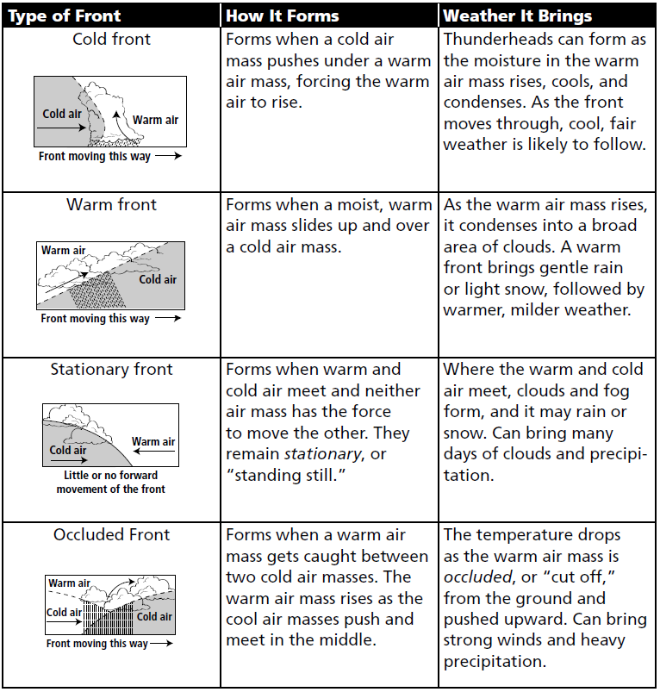

Weather Fronts
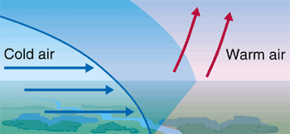
A cold weather front is defined as the changeover region where a cold air mass is replacing a warmer air mass. Cold weather fronts usually move from northwest to southeast. The air behind a cold front is colder and drier than the air in front. When a cold front passes through, temperatures can drop more than 15 degrees within an hour.
On a weather forecast map, a cold front is represented by a solid line with blue triangles along the front pointing towards the warmer air and in the direction of movement.
There is usually an obvious temperature change from one side of a cold front to the other. It has been known that temperatures east of a cold front could be approximately 55 degrees Fahrenheit while a short distance behind the cold front, the temperature can go down to 38 degrees. An abrupt temperature change over a short distance is a good indicator that a front is located somewhere in between.
A warm weather front is defined as the changeover region where a warm air mass is replacing a cold air mass. Warm fronts usually move from southwest to northeast and the air behind a warm front is warmer and moister than the air ahead of it. When a warm front passes, the air becomes noticeably warmer and more humid than it was before.
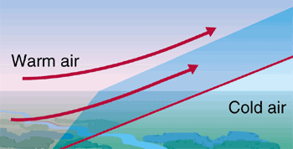
On a weather forecast map, a warm front is represented by a solid line with red semicircles pointing towards the colder air and in the direction of movement.
Again, there is typically a noticeable temperature change from one side of the warm front to the other, much the same as a cold front.
If colder air is replacing warmer air, it is a cold front, if warmer air is replacing cold air, then it is a warm front.

- What is the title of the article?
- What does weather refer to the condition of?
- What does weather o earth start with?
- When the sun’s heat warms our atmosphere, what two things happen?
- As air rises, what happens to its’ temperature?
- As moisture in the air cool, what happens to it?
- When the droplets of moisture become too heavy to remain suspended, what do they hall to earth as?
- What four ways do they do that?
- What is the title of the first sub-section?
- What do weather maps show?
- An air mass is a large body of air with similar what?
- Because air masses move, they can be clues to what?
- When air masses meet, they usually don’t mix. Why?
- What forms between the air masses?
- A cold front forms where cold air moves where?
- Which mass of air pushes below the other mass of air?
- What becomes scattered along cold fronts?
- A warm front forms when warm air moves where?
- Because warm air is less dense, where does it go?
- What type of precipitation occurs in a warm front?
- What happens in areas with stationary fronts?
- What is the title of the second sub-section?
- High pressure areas are shown with what symbol?
- What does the difference in air pressure result in?
- The air will move from the high pressure area to where?
ANSWER THESE ON YOUR OWN PAPER!!!
- Where does the wind blow away from? Where does the wind blow to?
- Low pressure areas are shown with what symbol?
- What is the title of the third sub-section?
- If air is above freezing, what will precipitation probably be?
- If air is below freezing, what will precipitation probably be?
- What is the title of the fourth sub-section?
- What is it that people say? And what are they referring to?
- What happens to air at higher temperatures?
- When can air hold more water vapor?
- What is the title of the fifth sub-section?
- What causes stronger wind?
- What is the title of the sixth sub-section?
- Because land and water retain heat, what continues to happen?
- What is the title of the next section?
- What is responsible for most changes in weather?
- Cold fronts occur when?
- Warm fronts occur when?
- Is local weather influenced by geography?
- What direction do most weather conditions travel in the United States?
- Where can a clue to tomorrow’s weather be found?
- What types of geographic features can affect local weather?
- Why do forecasters in Chicago give two sets of weather information?
- What are the five points to remember about geography and weather?
- What is the title of the last section?
- Draw the table with the type of front, how it forms, and the weather it brings in your notes. You will need this for our project.

