Name:_______________________________
Barycenter Concept Review

1. Is it true that the Earth revolves around the Sun?

2. What is the “center of gravity”?

3. Which diagram below is an accurate depiction of how the moon revolves around the Earth and the Earth revolves around the sun?

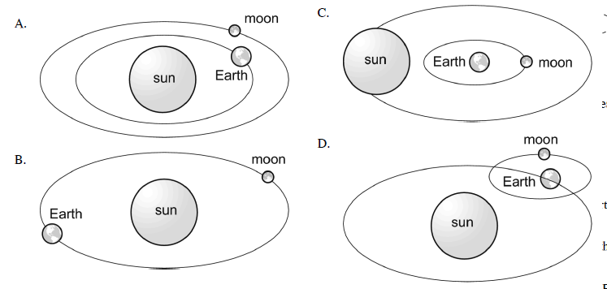
4. Which letter represents the barycenter in the following diagram?
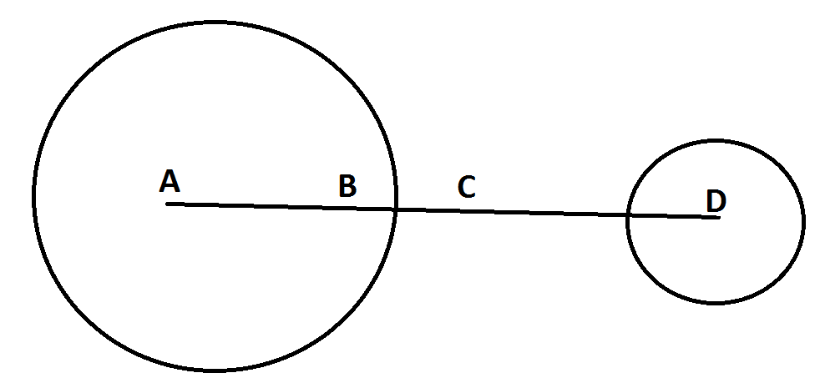

Kepler’s Laws of Planetary Motion Practice
1. Kepler’s 1st law is also known as the Law of ____________________________.

2. Kepler’s 1st Law: All planetary orbits are ______________________ in shape. Ellipses are similar to what shape?

3.Kepler’s 2nd Law (also known as the Law of ___________________________)- a line joining a planet to its sun sweeps out equal areas in equal times as the planets travel along its orbit.

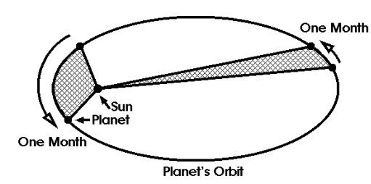
4. Use the diagram below to explain how and why a planet’s speed changes as it travels around its sun. Think about when a planet travels faster/slower in its orbit.

5. The diagram below shows the position of Earth (E) now. Where will Earth be in six months?
a) Near position 1 b) Near position 2 c) Near position 3 d) Near position 4

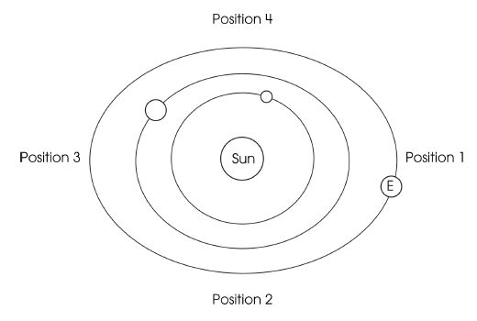

6. Kepler’s 3rd Law, also known as the Law of _______________________.
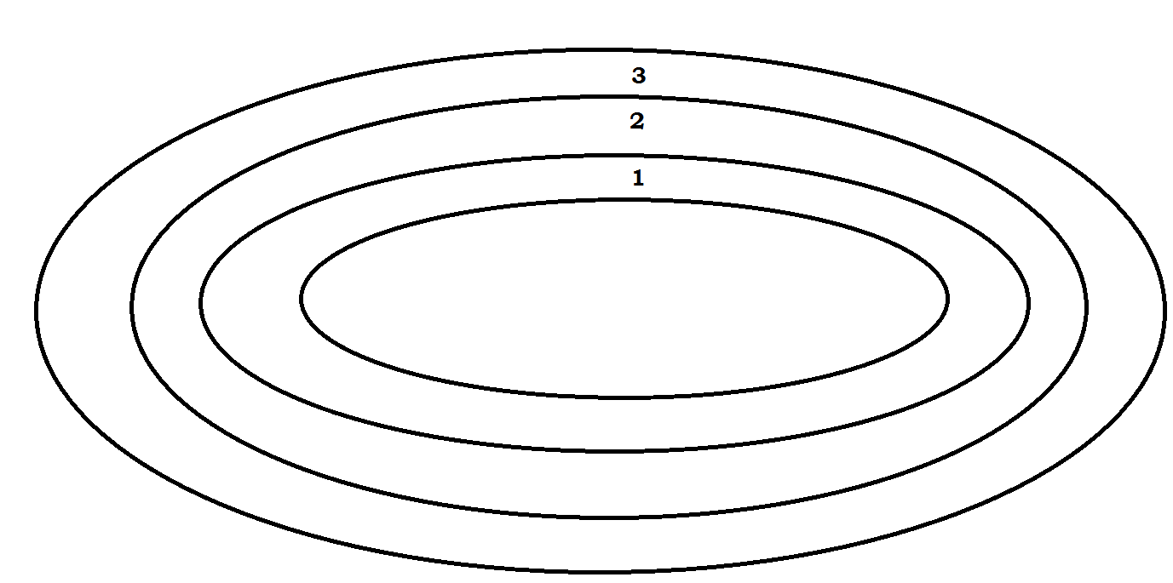
This law basically says that the farther away from the Sun an object like a planet is, the longer it will take to go around the Sun.

7. When you look at the diagram of a running track to the left, which lane is shortest? Which lane is longest?

8. If you went around the track one time in each lane, which lane would take you the most time? Which lap/ lane would take the least time?

9. Why is one year on Earth 365 days and one year on Mercury only 88 days?
a)Earth is larger than Mercury
b) Earth is smaller than Mercury
c) Earth is closer than Mercury to the sun
d) Earth is farther than Mercury from the sun

